Department of Mathematics

School of Advanced Sciences

MAT 1011 – Calculus for Engineers (MATLAB)

Experiment 2–A

Applications of Integration: finding area, volume of solid of revolution

Prepared by: Bimal Parajuli (20BDS0405)

**Question 1: (Classwork):**

**Calculate the area bounded by the curves y= 2-x^2 and the line y=-x, from x=-1 to 2 in MATLAB.**

Code:

clc

clear

close all

syms x

%given functions of the curves and intervals

f(x)=2-x^2;

g(x)=-x;

Interval=[-1,2];

a=Interval(1);

b=Interval(2);

%calculating the area enclosed

Area_enclosed=int(f(x)-g(x),a,b);

disp('The area bounded between the curves f(x) and g(x) is:');

disp(Area_enclosed);

%plotting the curve in a cartesian plane

fplot(f(x),[a,b])

grid on

hold on

fplot(g(x),[a,b])

hold off

xlabel('x-axis')

ylabel('y-axis')

legend ('y=f(x)','y=g(x)')

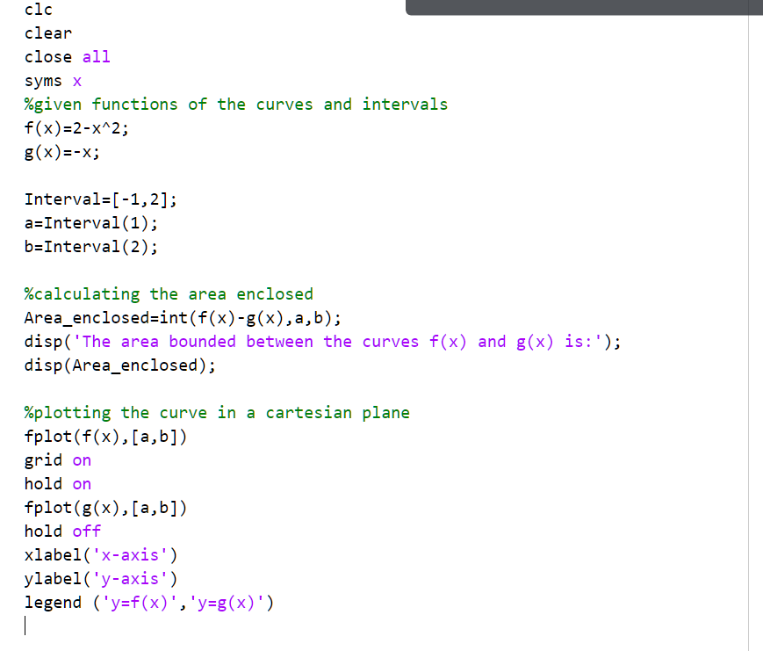

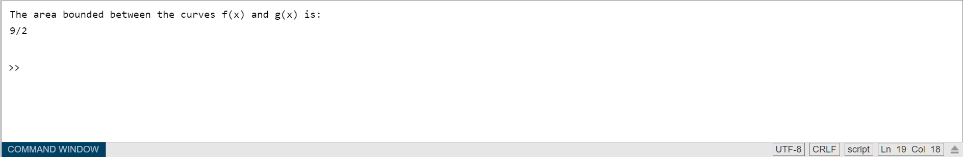

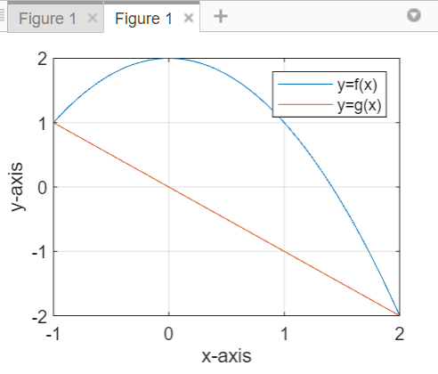

**Question 2: (Classwork)**

**Calculate the volume of solid generated by revolving the curve y= about the line y=1 from x=1 to x=4.**

Code:

clear

clc

close all

syms x

f(x)=sqrt(x); % Given function

yr=1; % Axis of revolution y=yr

I=[0,4]; % Interval of integration

a=I(1);b=I(2);

vol=pi*int((f(x)-yr)^2,a,b);

disp('Volume of the solid of revolution is: ');

disp(vol);

% Visualization of the solid of revolution

fx=matlabFunction(f);

xv = linspace(a,b,101); % Creates 101 points from a to b

[X,Y,Z] = cylinder(fx(xv)-yr);

Z = a+Z.*(b-a); % Extending the default unit height of the cylinder profile to the interval of integration.

surf(Z,Y+yr,X) % Plotting the solid of revolution about y=yr

hold on;

plot([a b],[yr yr],'-r','LineWidth',2); % Plotting the line y=yr

view(22,11); % 3-D graph viewpoint specification

xlabel('X-axis');

ylabel('Y-axis');

zlabel('Z-axis');

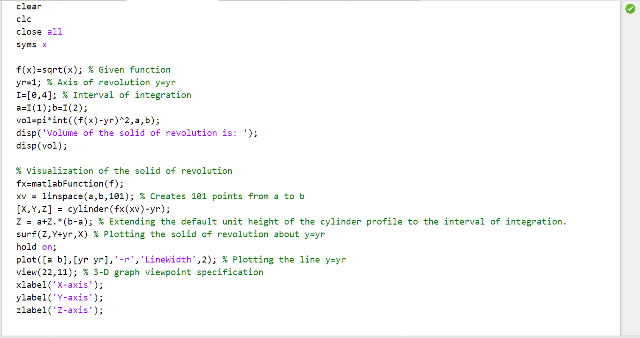

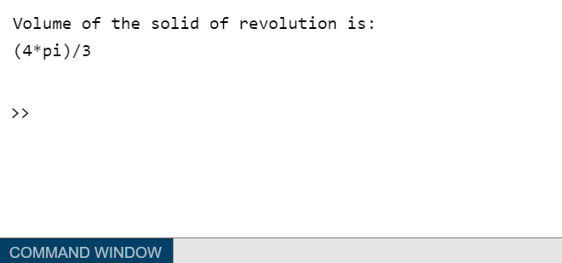

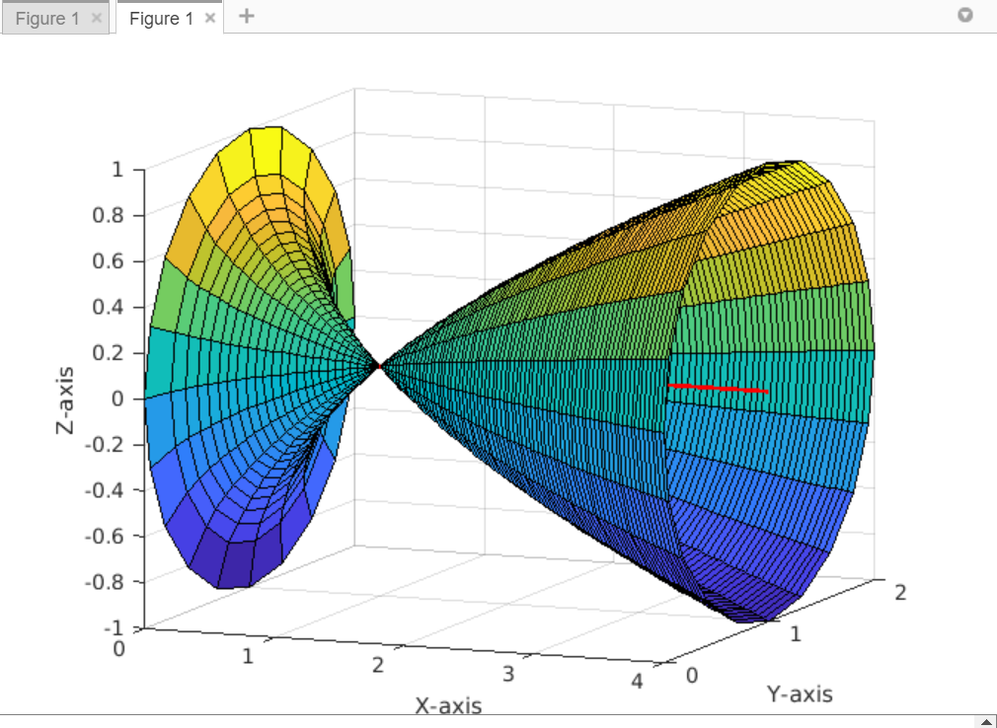

**Exercise Question 1:**

**Find the area of the region bounded by the curve y =-2x and the line y = x.**

Codes:

clc

clear

close all

syms x

%the given functions are:

g(x)=x;

f(x)=x^2-2*x;

Interval=[0,3];

a=Interval(1);

b=Interval(2);

%calculate and display the area

Area_enclosed=int(g(x)-f(x),a,b);

disp('the area enclosed by the curves is:')

disp(Area_enclosed)

%plotting the curves on cartesian plane.

fplot(f(x),[a,b])

grid on

hold on

fplot(g(x),[a,b])

hold off

xlabel('x-axia')

ylabel('y-axia')

legend('y=f(x)','y=g(x)')

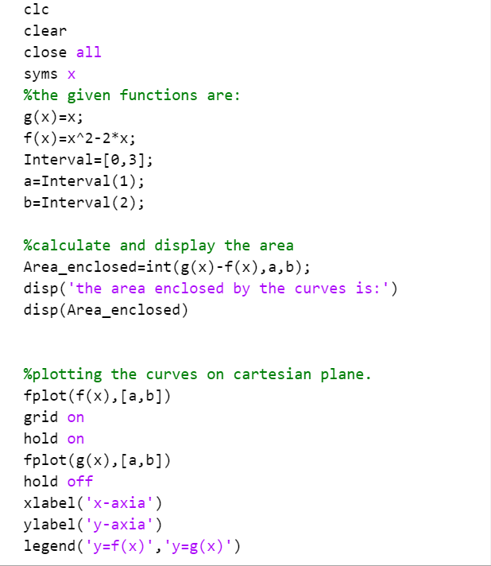

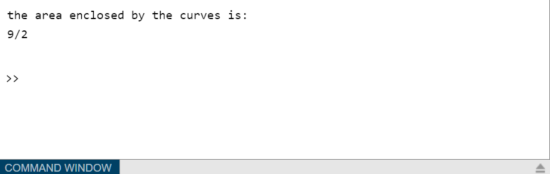

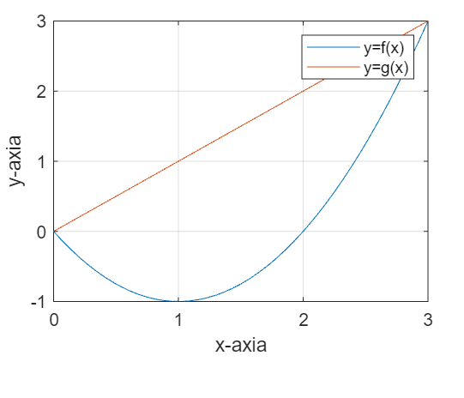

**Exercise Question 2:**

**To find the area of the region bounded by the curves x = , y = x − 2 in the first quadrant.**

**Codes:**

clc

clear

close all

syms x

%the given functions and the intervals of their intersections.

f(x)=sqrt(x);

g(x)=x-2;

interval=[0,2,4];

a=interval(1);

b=interval(2);

c=interval(3);

%calculating the area enclosed by two steps integration and summing up.

t = int(f(x),a,b);

u = int(f(x)-g(x),b,c);

total_area = t + u;

disp('The area in the first quadrant encclosed by the curves is')

disp(total_area)

%plotting the curves in cartesian plane.

fplot(f(x),[a,c])

hold on

grid on

fplot(g(x),[b,c])

hold off

xlabel('x-axis')

ylabel('y-axis')

legend('y=f(x)','y=g(x)')

title('Calculating the area enclosed by two curves in the first quadrant')

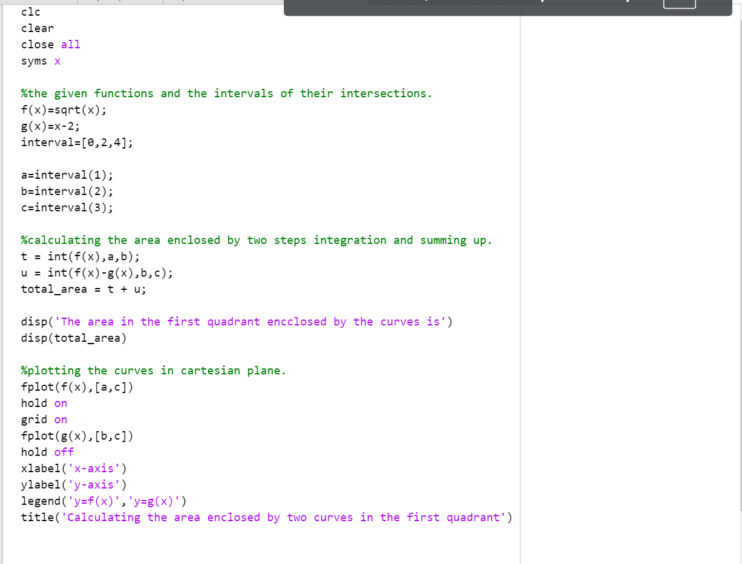 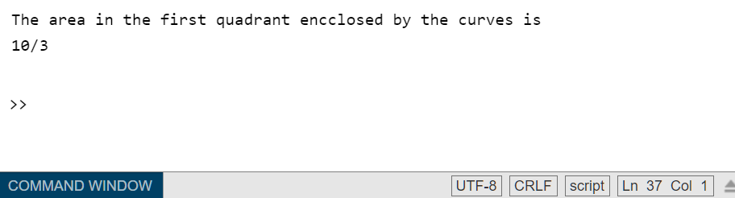

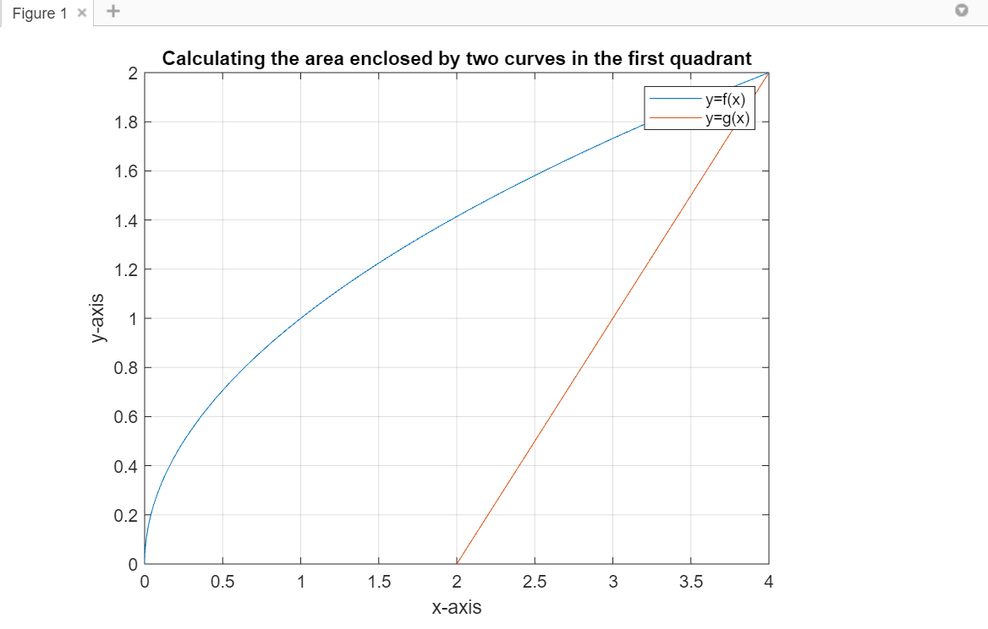

**Exercise Question 3:**

**Find the area of the region bounded by the curves x = and x = .**

**Codes:**

clc

clear

close all

syms x

f(x)=x^(1/3);

g(x)=x^(1/2);

interval=[0,1];

a=interval(1);

b=interval(2);

area=int(f(x)-g(x),a,b);

disp('The area enclosed by the given curves is')

disp(area)

fplot(f(x),[a,b])

hold on

grid on

fplot(g(x),[a,b])

hold off

xlabel('x-axis')

ylabel('y-axis')

legend('f(x)','g(x)')

title("Calculating the area enclosed by these two curves")

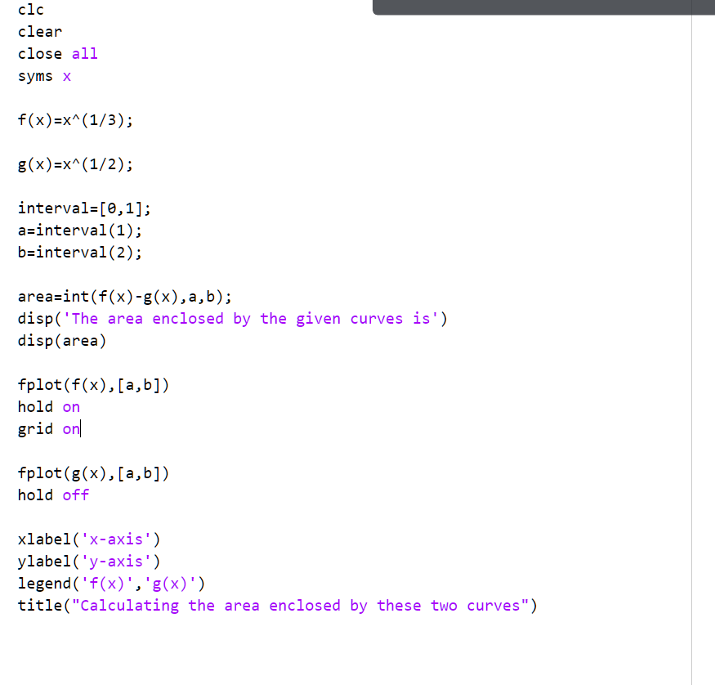

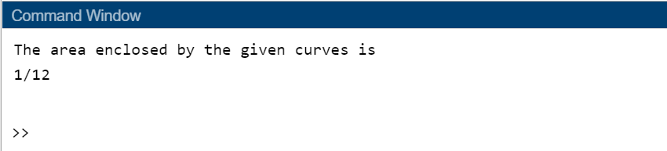

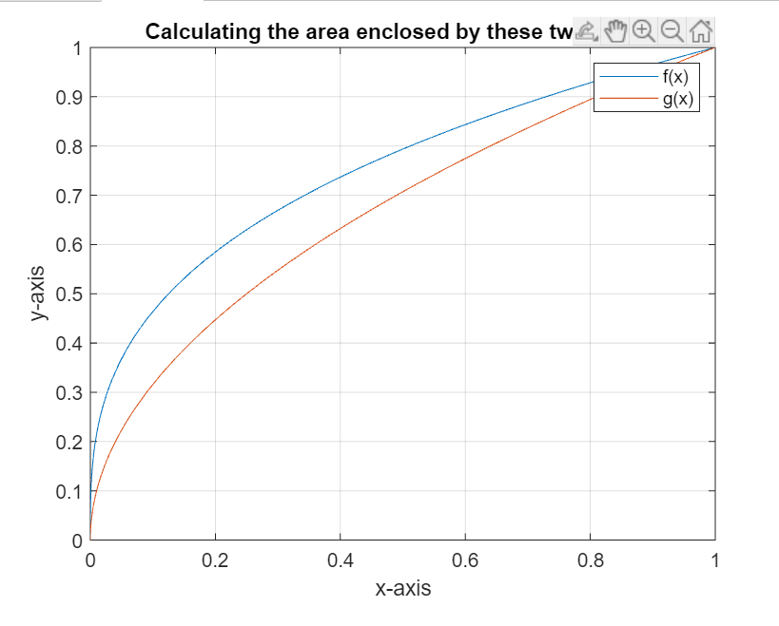

**Exercise question 4:**

**Find the volume of the solid generated by revolving about the x − axis the region bounded by the curve y= , the x − axis, and the lines x = 0 and x = 2 .**

**Codes**:

clc

clear

close all

syms x

%given function

f(x)=4/(x^2+4);

interval=[0,2];

a=interval(1);

b=interval(2);

%calculating the

volume=int(pi*(f(x)-0)^2,a,b);

disp("The volume of the solid of revolution is:")

disp(volume)

%%plotting the curve in 3d-space

fx=matlabFunction(f);

xv = linspace(a,b,101); % Creates 101 points from a to b

[X,Y,Z] = cylinder(fx(xv)-0);

Z = a+Z.*(b-a); % Extending the default unit height of the

%cylinder profile to the interval of integration.

surf(Z,Y+0,X) % Plotting the solid of revolution about y=yr

hold on;

plot([a b],[0 0],'-r','LineWidth',2); % Plotting the line y=yr

view(22,11); % 3-D graph viewpoint specification

xlabel('X-axis');

ylabel('Y-axis');

zlabel('Z-axis');

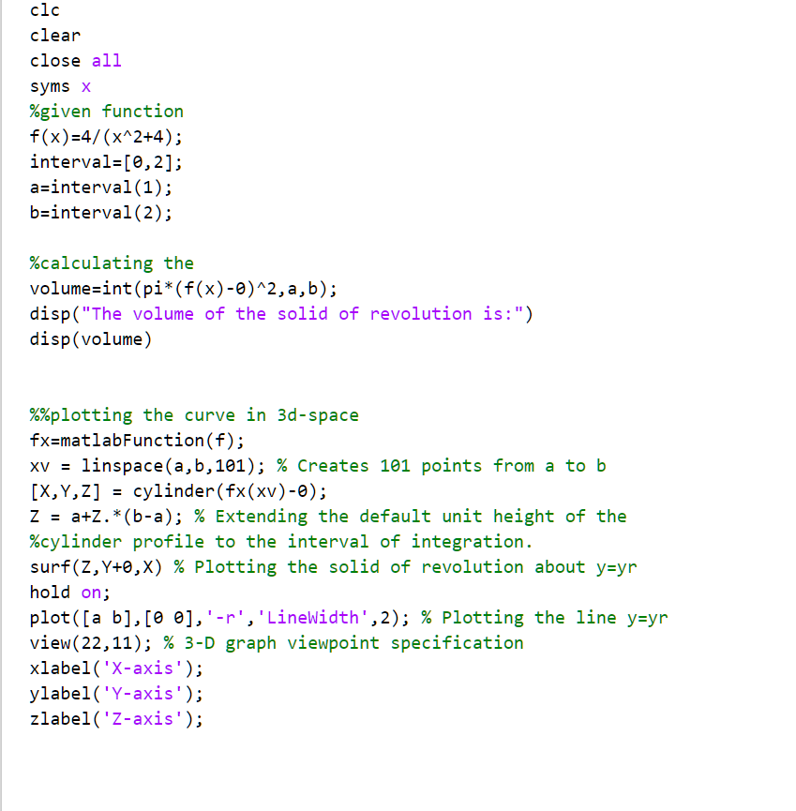

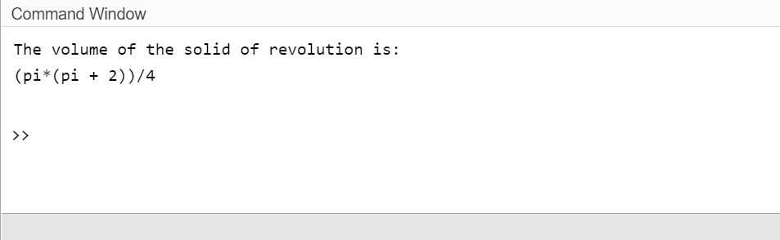

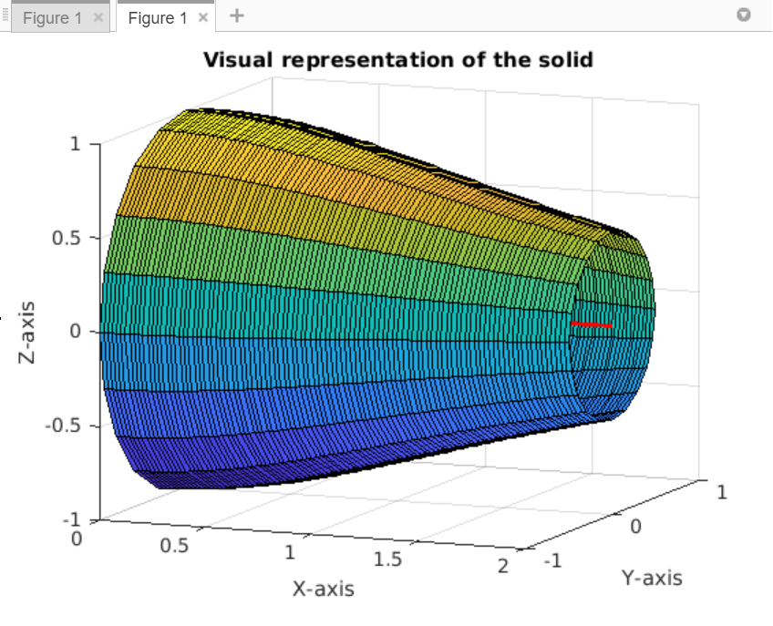

*--THE END--*

**Page intentionally left blank**

**Page intentionally left blank**